
CP2406 Programming 3 Assignment 1

Haonan Zhang
[Company Name]

User Stories
- As a user, I want to design my own city including traffic lights locations , roads locations and also numbers of cars.

- As a user, I want it can be saved and loaded in case I need to leave or stop the program.

- As a user, I want the simulator can contains more pictures and easy to recognize the items.

- As a user, I want the simulator can follow the traffic rules such as stop at red light.

- As a user, I suppose all the cars follow the rules and no car accident.

Developer Stories
- As a developer, the application needs to have city editing mode and simulation mode as well.

- As a developer, the application needs to store the map information locally to reuse the map.

- As a developer, the GUI needs to be clear and simply as more user friendly as I can.

- As a developer, the traffic light should also be able to change by user so that user could control the flow.

UML Diagram
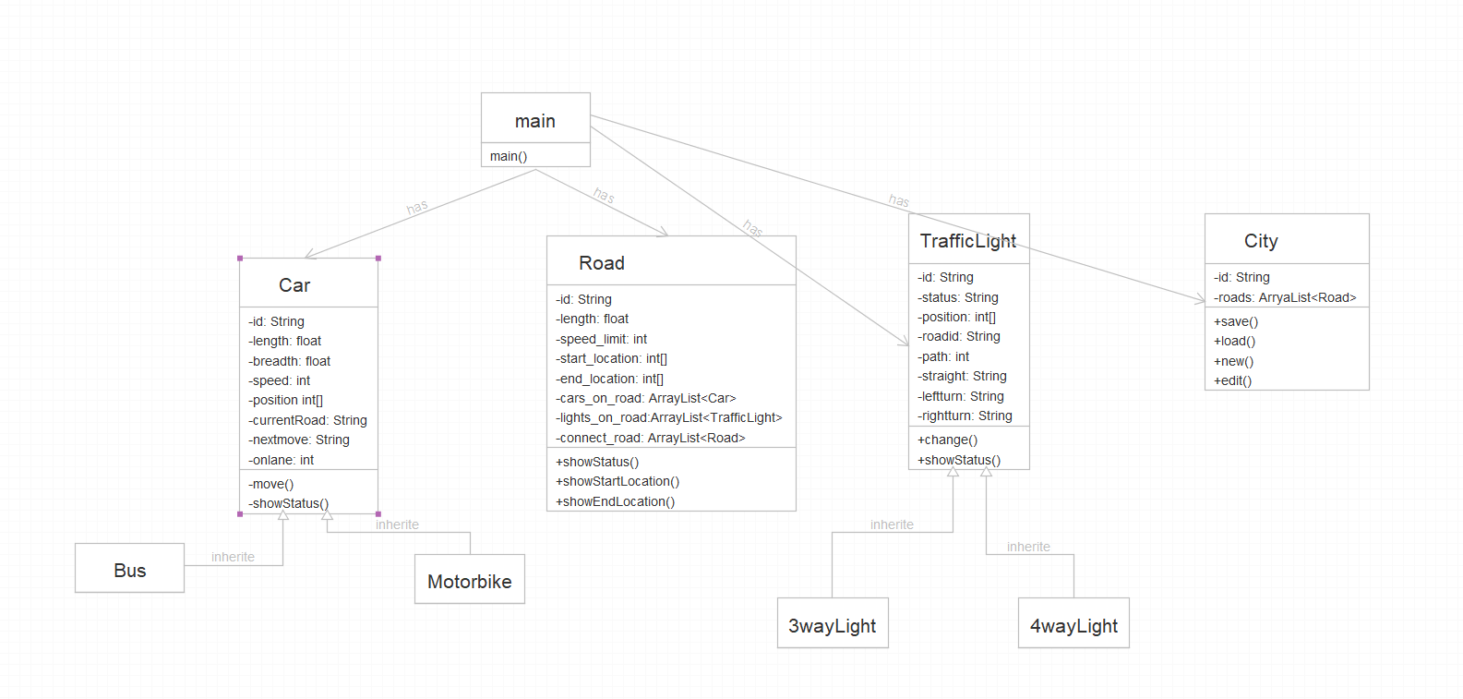
GitHub
https://github.com/mjjzhn/Traffic_Simulator
